**DATE OF PRACTICAL** – 30 AUGUST 2022

**PROBLEM STATEMENT :** Create an Android Application to print a simple text on screen.

OBJECTIVE: To print a Simple Text On Screen.

**AndroidManifest.xml**

<?xml version="1.0" encoding="utf-8"?>

<manifest xmlns:android="http://schemas.android.com/apk/res/android"

xmlns:tools="http://schemas.android.com/tools">

<application

android:allowBackup="true"

android:dataExtractionRules="@xml/data_extraction_rules"

android:fullBackupContent="@xml/backup_rules"

android:icon="@mipmap/ic_launcher"

android:label="@string/app_name"

android:roundIcon="@mipmap/ic_launcher_round"

android:supportsRtl="true"

android:theme="@style/Theme.MyApplication"

tools:targetApi="31">

<activity

android:name=".MainActivity"

android:exported="true">

<intent-filter>

<action android:name="android.intent.action.MAIN" />

<category android:name="android.intent.category.LAUNCHER" />

</intent-filter>

<meta-data

android:name="android.app.lib_name"

android:value="" />

</activity>

</application>

</manifest>

**Colors.xml**

<?xml version="1.0" encoding="utf-8"?>

<resources>

<color name="purple_200">#FFBB86FC</color>

<color name="purple_500">#FF6200EE</color>

<color name="purple_700">#FF3700B3</color>

<color name="teal_200">#FF03DAC5</color>

<color name="teal_700">#FF018786</color>

<color name="black">#FF000000</color>

<color name="white">#FFFFFFFF</color>

</resources>

**Strings.xml**

<resources>

<string name="app_name">My Application</string>

</resources>

**Activity_main.xml**

<?xml version="1.0" encoding="utf-8"?>

<androidx.constraintlayout.widget.ConstraintLayout xmlns:android="http://schemas.android.com/apk/res/android"

xmlns:app="http://schemas.android.com/apk/res-auto"

xmlns:tools="http://schemas.android.com/tools"

android:layout_width="match_parent"

android:layout_height="match_parent"

tools:context=".MainActivity">

<TextView

android:layout_width="wrap_content"

android:layout_height="wrap_content"

android:text="Himani Taneja"

android:textSize="50dp"

android:textColor="@color/black"

app:layout_constraintBottom_toBottomOf="parent"

app:layout_constraintEnd_toEndOf="parent"

app:layout_constraintStart_toStartOf="parent"

app:layout_constraintTop_toTopOf="parent" />

</androidx.constraintlayout.widget.ConstraintLayout>

**MainActivity.java**

package com.example.myapplication;

import androidx.appcompat.app.AppCompatActivity;

import android.os.Bundle;

public class MainActivity extends AppCompatActivity {

@Override

protected void onCreate(Bundle savedInstanceState) {

super.onCreate(savedInstanceState);

setContentView(R.layout.activity_main);

}

}

**OUTPUT**

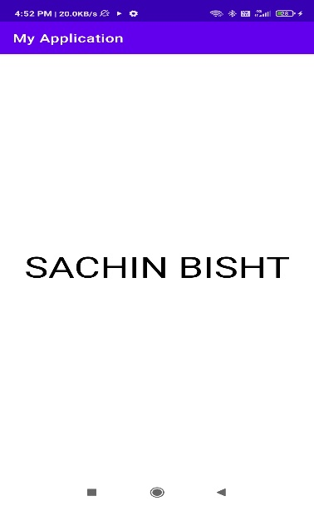

Himani Taneja

**DATE OF PRACTICAL** – 30 AUGUST 2022

**PROBLEM STATEMENT :** Create an Android Application to change the background colour on button click.

**AndroidManifest.xml**

<?xml version="1.0" encoding="utf-8"?>

<manifest xmlns:android="http://schemas.android.com/apk/res/android"

xmlns:tools="http://schemas.android.com/tools">

<application

android:allowBackup="true"

android:dataExtractionRules="@xml/data_extraction_rules"

android:fullBackupContent="@xml/backup_rules"

android:icon="@mipmap/ic_launcher"

android:label="@string/app_name"

android:roundIcon="@mipmap/ic_launcher_round"

android:supportsRtl="true"

android:theme="@style/Theme.MyApplication1"

tools:targetApi="31">

<activity

android:name=".MainActivity"

android:exported="true">

<intent-filter>

<action android:name="android.intent.action.MAIN" />

<category android:name="android.intent.category.LAUNCHER" />

</intent-filter>

</activity>

</application>

</manifest>

**Colors.xml**

<?xml version="1.0" encoding="utf-8"?>

<resources>

<color name="purple_200">#FFBB86FC</color>

<color name="purple_500">#FF6200EE</color>

<color name="purple_700">#FF3700B3</color>

<color name="teal_200">#FF03DAC5</color>

<color name="teal_700">#FF018786</color>

<color name="black">#FF000000</color>

<color name="white">#FFFFFFFF</color>

</resources>

**Strings.xml**

<resources>

<string name="app_name">My Application1</string>

</resources>

**Activity_main.xml**

<?xml version="1.0" encoding="utf-8"?>

<RelativeLayout xmlns:android="http://schemas.android.com/apk/res/android"

xmlns:app="http://schemas.android.com/apk/res-auto"

xmlns:tools="http://schemas.android.com/tools"

android:id="@+id/l2"

android:layout_width="match_parent"

android:layout_height="match_parent"

tools:context=".MainActivity"

>

<Button

android:id="@+id/b1"

android:layout_width="wrap_content"

android:layout_height="wrap_content"

android:textSize="30dp"

android:layout_marginLeft="164dp"

android:layout_marginTop="800px"

android:text="red"

/>

</RelativeLayout>

**MainActivity.java**

package com.example.myapplication1;

import android.graphics.Color;

import android.os.Bundle;

import android.view.View;

import android.widget.Button;

import android.widget.RelativeLayout;

import androidx.appcompat.app.AppCompatActivity;

public class MainActivity extends AppCompatActivity {

Button b1;

RelativeLayout l1;

protected void OnCreate(Bundle s) {

b1 = findViewById(R.id.b1);

l1 = findViewById(R.id.l2);

b1.setOnClickListener(new View.OnClickListener() {

@Override

public void onClick(View view) {

l1.setBackgroundColor(Color.RED);

}

});

}

}

**OUTPUT**

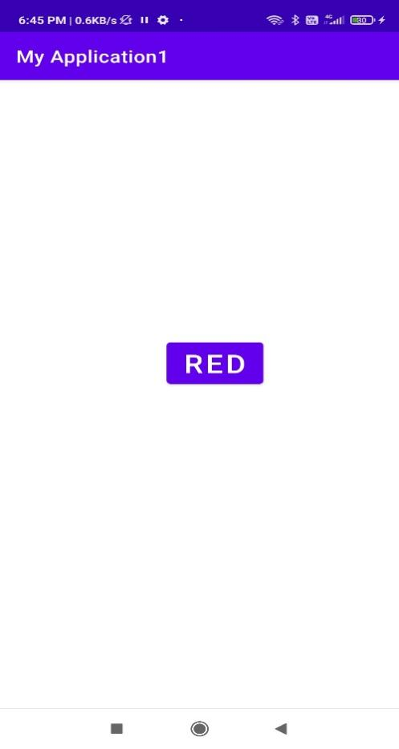 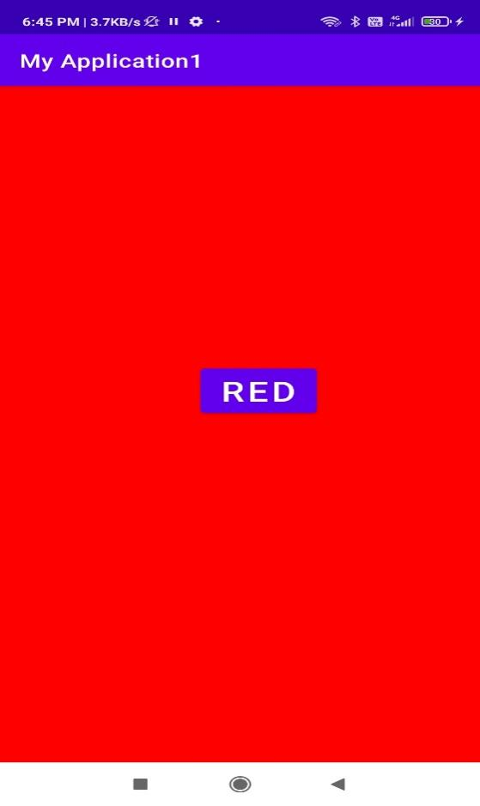

**DATE OF PRACTICAL-**06 SEPTEMBER 2022

**PROBLEM STATEMENT:** Create A Android Application To Change The Background Color Of A Text Box With The Click Of The Button.

**OBJECTIVE**: Change The Background Color Of Text Box When Clicked On Button.

**AndroidManifest.xml**

<?xml version="1.0" encoding="utf-8"?>

<manifest xmlns:android="http://schemas.android.com/apk/res/android"

xmlns:tools="http://schemas.android.com/tools">

<application

android:allowBackup="true"

android:dataExtractionRules="@xml/data_extraction_rules"

android:fullBackupContent="@xml/backup_rules"

android:icon="@mipmap/ic_launcher"

android:label="@string/app_name"

android:roundIcon="@mipmap/ic_launcher_round"

android:supportsRtl="true"

android:theme="@style/Theme.Sa"

tools:targetApi="31">

<activity

android:name=".MainActivity"

android:exported="true">

<intent-filter>

<action android:name="android.intent.action.MAIN" />

<category android:name="android.intent.category.LAUNCHER" />

</intent-filter>

<meta-data

android:name="android.app.lib_name"

android:value="" />

</activity>

</application>

</manifest>

**Colors.xml**

<?xml version="1.0" encoding="utf-8"?>

<resources>

<color name="purple_200">#FFBB86FC</color>

<color name="purple_500">#FF6200EE</color>

<color name="purple_700">#FF3700B3</color>

<color name="teal_200">#FF03DAC5</color>

<color name="teal_700">#FF018786</color>

<color name="black">#FF000000</color>

<color name="white">#FFFFFFFF</color>

</resources>

**Strings.xml**

<resources>

<string name="app_name">sa</string>

</resources>

**Activity_main.xml**

<?xml version="1.0" encoding="utf-8"?>

<RelativeLayout xmlns:android="http://schemas.android.com/apk/res/android"

xmlns:app="http://schemas.android.com/apk/res-auto"

xmlns:tools="http://schemas.android.com/tools"

android:layout_width="match_parent"

android:layout_height="match_parent"

tools:context=".MainActivity">

<Button

android:id="@+id/b1"

android:layout_width="wrap_content"

android:layout_height="wrap_content"

android:text="red"

android:textSize="30dp"

android:layout_marginTop="150dp"

android:layout_marginLeft="160dp"

/>

<TextView

android:id="@+id/t1"

android:layout_width="200dp"

android:layout_height="200dp"

android:layout_marginTop="290dp"

android:layout_marginLeft="110dp"

/>

</RelativeLayout>

**MainActivity.java**

package com.example.sa;

import androidx.appcompat.app.AppCompatActivity;

import android.annotation.SuppressLint;

import android.graphics.Color;

import android.os.Bundle;

import android.view.View;

import android.widget.Button;

import android.widget.TextView;

public class MainActivity extends AppCompatActivity {

Button b2;

TextView t2;

@SuppressLint("MissingInflatedId")

@Override

protected void onCreate(Bundle savedInstanceState) {

super.onCreate(savedInstanceState);

setContentView(R.layout.activity_main);

b2=findViewById(R.id.b1);

t2=findViewById(R.id.t1);

b2.setOnClickListener(new View.OnClickListener() {

@Override

public void onClick(View view) {

t2.setBackgroundColor(Color.RED);

}

});

}

}

**OUTPUT**

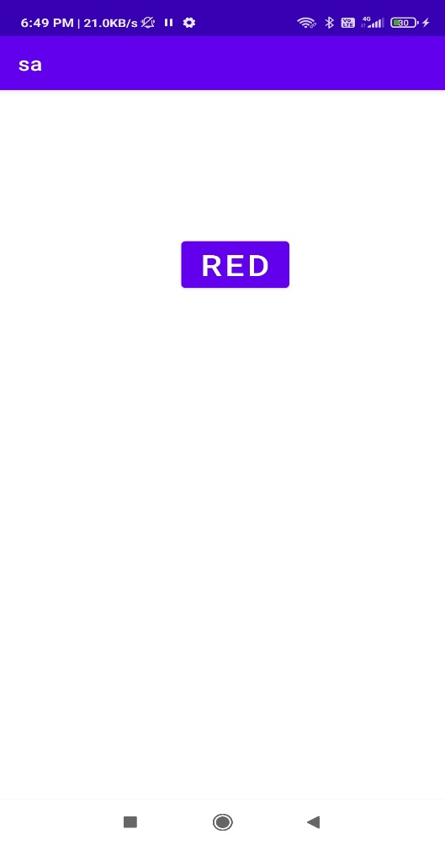 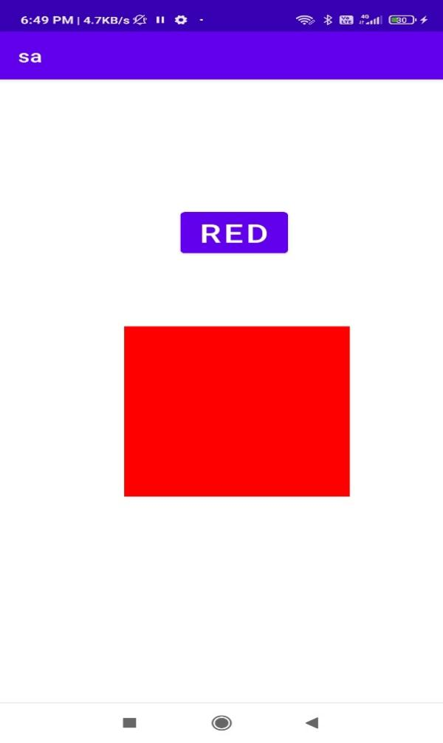

**DATE OF PRACTICAL-** 06 SEPTEMBER 2022

**PROBLEM STATEMENT:** Create A Android Application To Show the Significance Of Activity Life Cycle.

**OBJECTIVE**: To See The Use Of Different Method Of Android Life Cycle.

**AndroidManifest.xml**

<?xml version="1.0" encoding="utf-8"?>

<manifest xmlns:android="http://schemas.android.com/apk/res/android"

xmlns:tools="http://schemas.android.com/tools">

<application

android:allowBackup="true"

android:dataExtractionRules="@xml/data_extraction_rules"

android:fullBackupContent="@xml/backup_rules"

android:icon="@mipmap/ic_launcher"

android:label="@string/app_name"

android:roundIcon="@mipmap/ic_launcher_round"

android:supportsRtl="true"

android:theme="@style/Theme.Activity"

tools:targetApi="31">

<activity

android:name=".MainActivity"

android:exported="true">

<intent-filter>

<action android:name="android.intent.action.MAIN" />

<category android:name="android.intent.category.LAUNCHER" />

</intent-filter>

<meta-data

android:name="android.app.lib_name"

android:value="" />

</activity>

</application>

</manifest>

**Colors.xml**

<?xml version="1.0" encoding="utf-8"?>

<resources>

<color name="purple_200">#FFBB86FC</color>

<color name="purple_500">#FF6200EE</color>

<color name="purple_700">#FF3700B3</color>

<color name="teal_200">#FF03DAC5</color>

<color name="teal_700">#FF018786</color>

<color name="black">#FF000000</color>

<color name="white">#FFFFFFFF</color>

<color name="green">#57EB0A</color>

</resources>

**Strings.xml**

<resources>

<string name="app_name">activity</string>

</resources>

**Activity_main.xml**

<?xml version="1.0" encoding="utf-8"?>

<RelativeLayout xmlns:android="http://schemas.android.com/apk/res/android"

xmlns:app="http://schemas.android.com/apk/res-auto"

xmlns:tools="http://schemas.android.com/tools"

android:layout_width="match_parent"

android:layout_height="match_parent"

tools:context=".MainActivity"

android:gravity="center">

<TextView

android:layout_width="wrap_content"

android:layout_height="wrap_content"

android:text="Hello World!"

android:textSize="40dp"

/>

</RelativeLayout>

**MainActivity.java**

package com.example.activity;

import androidx.appcompat.app.AppCompatActivity;

import android.os.Bundle;

import android.util.Log;

import android.widget.Toast;

public class MainActivity extends AppCompatActivity {

@Override

protected void onCreate(Bundle savedInstanceState) {

super.onCreate(savedInstanceState);

setContentView(R.layout.activity_main);

Log.d("lifecycle","onCreate invoked");

}

@Override

protected void onStart()

{

super.onStart();

Log.d("lifecycle","onStart invoked");

}

@Override

protected void onResume()

{

super.onResume();

Log.d("lifecycle","onResume invoked");

}

@Override

protected void onPause()

{

super.onPause();

Log.d("lifecycle","onPause invoked");

}

@Override

protected void onStop()

{

super.onStop();

Log.d("lifecycle","onStop invoked");

}

@Override

protected void onRestart()

{

super.onRestart();

Log.d("lifecycle","onRestart invoked");

}

@Override

protected void onDestroy() {

super.onDestroy();

Log.d("lifecycle", "onDestroy invoked");

}

}

**OUTPUT**

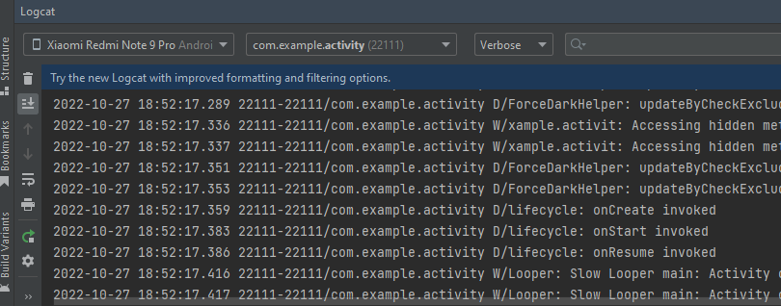

**DATE OF PRACTICAL-**13 SEPTEMBER 2022

**PROBLEM STATEMENT:** Create A Android Application To Sum of two numbers on Button Click.

**OBJECTIVE**: To sum of two number.

**AndroidManifest.xml**

<?xml version="1.0" encoding="utf-8"?>

<manifest xmlns:android="http://schemas.android.com/apk/res/android"

xmlns:tools="http://schemas.android.com/tools">

<application

android:allowBackup="true"

android:dataExtractionRules="@xml/data_extraction_rules"

android:fullBackupContent="@xml/backup_rules"

android:icon="@mipmap/ic_launcher"

android:label="@string/app_name"

android:roundIcon="@mipmap/ic_launcher_round"

android:supportsRtl="true"

android:theme="@style/Theme.Sam"

tools:targetApi="31">

<activity

android:name=".MainActivity"

android:exported="true">

<intent-filter>

<action android:name="android.intent.action.MAIN" />

<category android:name="android.intent.category.LAUNCHER" />

</intent-filter>

<meta-data

android:name="android.app.lib_name"

android:value="" />

</activity>

</application>

</manifest>

**Colors.xml**

<?xml version="1.0" encoding="utf-8"?>

<resources>

<color name="purple_200">#FFBB86FC</color>

<color name="purple_500">#FF6200EE</color>

<color name="purple_700">#FF3700B3</color>

<color name="teal_200">#FF03DAC5</color>

<color name="teal_700">#FF018786</color>

<color name="black">#FF000000</color>

<color name="white">#FFFFFFFF</color>

<color name="blue">#03A9F4</color>

<color name="green">#2EE60D</color>

<color name="red">#DA2416</color>

</resources>

**Strings.xml**

<resources>

<string name="app_name">sam</string>

</resources>

**Activity_main.xml**

<?xml version="1.0" encoding="utf-8"?>

<RelativeLayout xmlns:android="http://schemas.android.com/apk/res/android"

xmlns:app="http://schemas.android.com/apk/res-auto"

xmlns:tools="http://schemas.android.com/tools"

android:layout_width="match_parent"

android:layout_height="match_parent"

tools:context=".MainActivity"

android:background="@color/blue"

>

<EditText

android:id="@+id/e1"

android:layout_width="353dp"

android:layout_height="60dp"

android:layout_marginStart="30dp"

android:layout_marginTop="30dp"

android:backgroundTint="@color/black"

android:textColor="@color/green"

android:textSize="40dp"

android:layout_marginEnd="30dp"

android:layout_marginBottom="30dp"

android:inputType="number"

android:background="@color/white"

/>

<EditText

android:id="@+id/e2"

android:layout_width="353dp"

android:layout_height="60dp"

android:layout_below="@id/e1"

android:layout_alignParentStart="true"

android:layout_alignParentEnd="true"

android:layout_marginStart="30dp"

android:layout_marginTop="20dp"

android:backgroundTint="@color/black"

android:textColor="@color/green"

android:textSize="40dp"

android:layout_marginEnd="28dp"

android:layout_marginBottom="20dp"

android:background="@color/white"

android:inputType="number"

/>

<TextView

android:id="@+id/t1"

android:layout_width="374dp"

android:layout_height="64dp"

android:layout_below="@id/e2"

android:textColor="@color/red"

android:textSize="50dp"

android:layout_marginStart="20dp"

android:layout_marginTop="62dp"

android:layout_marginEnd="20dp"

android:layout_marginBottom="20dp"

android:background="#EC9999"

/>

<Button

android:id="@+id/b1"

android:layout_width="wrap_content"

android:layout_height="wrap_content"

android:text="sum"

android:textSize="40dp"

android:layout_marginTop="390dp"

android:layout_marginLeft="150dp"

/>

</RelativeLayout>

**MainActivity.java**

package com.example.sam;

import androidx.appcompat.app.AppCompatActivity;

import android.annotation.SuppressLint;

import android.os.Bundle;

import android.view.View;

import android.widget.Button;

import android.widget.EditText;

import android.widget.TextView;

public class MainActivity extends AppCompatActivity {

Button bt1;

TextView tv1;

EditText et1,et2;

@SuppressLint("MissingInflatedId")

@Override

protected void onCreate(Bundle savedInstanceState) {

super.onCreate(savedInstanceState);

setContentView(R.layout.activity_main);

tv1=findViewById(R.id.t1);

et1=findViewById(R.id.e1);

et2=findViewById(R.id.e2);

bt1=findViewById(R.id.b1);

bt1.setOnClickListener(new View.OnClickListener() {

@Override

public void onClick(View view) {

int a,b,c;

if((et1.getText().toString().length())==0)

{

et1.setText("0");

}

if((et2.getText().toString().length())==0)

{

et2.setText("0");

}

a=Integer.parseInt(et1.getText().toString());

b=Integer.parseInt(et2.getText().toString());

c=a+b;

tv1.setText(String.valueOf(c));

}

});

}

}

**OUTPUT**

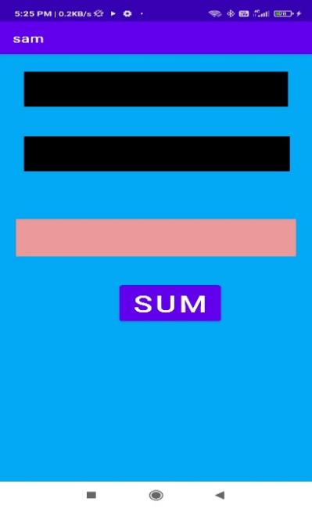

**DATE OF PRACTICAL-**13 SEPTEMBER 2022

**PROBLEM STATEMENT:** Create A Simple Calculator.

**OBJECTIVE**: Create A calculator for basic calculation like Addition , Subtraction , Multiplication and Division.

**AndroidManifest.xml**

<?xml version="1.0" encoding="utf-8"?>

<manifest xmlns:android="http://schemas.android.com/apk/res/android"

xmlns:tools="http://schemas.android.com/tools">

<application

android:allowBackup="true"

android:dataExtractionRules="@xml/data_extraction_rules"

android:fullBackupContent="@xml/backup_rules"

android:icon="@mipmap/ic_launcher"

android:label="@string/app_name"

android:roundIcon="@mipmap/ic_launcher_round"

android:supportsRtl="true"

android:theme="@style/Theme.Calculator"

tools:targetApi="31">

<activity

android:name=".MainActivity"

android:exported="true">

<intent-filter>

<action android:name="android.intent.action.MAIN" />

<category android:name="android.intent.category.LAUNCHER" />

</intent-filter>

<meta-data

android:name="android.app.lib_name"

android:value="" />

</activity>

</application>

</manifest>

**Colors.xml**

<?xml version="1.0" encoding="utf-8"?>

<resources>

<color name="purple_200">#FFBB86FC</color>

<color name="purple_500">#FF6200EE</color>

<color name="purple_700">#FF3700B3</color>

<color name="teal_200">#FF03DAC5</color>

<color name="teal_700">#FF018786</color>

<color name="black">#FF000000</color>

<color name="white">#FFFFFFFF</color>

<color name="GREEN">#03F307</color>

<color name="YELLOW">#FAD107</color>

<color name="BLUE">#075EF3</color>

<color name="blue">#A669F5E0</color>

<color name="c">#2B6BEB</color>

<color name="purple">#8606BD</color>

</resources>

**Strings.xml**

<resources>

<string name="app_name">calculator</string>

</resources>

**Activity_main.xml**

<?xml version="1.0" encoding="utf-8"?>

<RelativeLayout xmlns:android="http://schemas.android.com/apk/res/android"

xmlns:app="http://schemas.android.com/apk/res-auto"

xmlns:tools="http://schemas.android.com/tools"

android:layout_width="match_parent"

android:layout_height="match_parent"

tools:context=".MainActivity"

android:background="@color/c"

>

<EditText

android:id="@+id/e1"

android:layout_width="match_parent"

android:layout_height="wrap_content"

android:layout_marginStart="30dp"

android:layout_marginTop="30dp"

android:layout_marginEnd="30dp"

android:layout_marginBottom="30dp"

android:inputType="number"

android:outlineAmbientShadowColor="@color/GREEN"

android:textSize="35dp"

android:background="@color/white"

/>

<EditText

android:id="@+id/e2"

android:layout_width="353dp"

android:layout_height="wrap_content"

android:layout_below="@id/e1"

android:layout_alignParentStart="true"

android:layout_alignParentEnd="true"

android:layout_marginStart="30dp"

android:layout_marginTop="20dp"

android:layout_marginEnd="28dp"

android:layout_marginBottom="20dp"

android:background="@color/white"

android:inputType="number"

android:outlineAmbientShadowColor="@color/black"

android:textSize="35dp" />

<TextView

android:id="@+id/t1"

android:layout_width="374dp"

android:layout_height="64dp"

android:layout_below="@id/e2"

android:layout_marginStart="20dp"

android:layout_marginTop="62dp"

android:layout_marginEnd="20dp"

android:layout_marginBottom="20dp"

android:background="#EC9999"

android:textColor="@color/GREEN"

android:textSize="35dp" />

<LinearLayout

android:layout_width="wrap_content"

android:layout_height="wrap_content"

android:layout_below="@+id/t1"

>

<Button

android:id="@+id/b1"

android:layout_width="wrap_content"

android:layout_height="66dp"

android:layout_margin="20dp"

android:backgroundTint="#B6271D"

android:text="ADD"

android:textSize="20dp" />

<Button

android:id="@+id/b2"

android:layout_width="wrap_content"

android:layout_height="62dp"

android:layout_margin="20dp"

android:backgroundTint="#B6271D"

android:text="sub"

android:textSize="20dp"

/>

<Button

android:id="@+id/b3"

android:layout_width="wrap_content"

android:layout_height="67dp"

android:layout_below="@id/t1"

android:layout_margin="20dp"

android:backgroundTint="#B6271D"

android:text="div"

android:textSize="20dp" />

</LinearLayout>

<Button

android:id="@+id/b4"

android:layout_width="wrap_content"

android:layout_height="67dp"

android:layout_alignParentStart="true"

android:layout_alignParentBottom="true"

android:layout_marginStart="47dp"

android:layout_marginTop="372dp"

android:layout_marginEnd="81dp"

android:layout_marginBottom="157dp"

android:layout_toStartOf="@+id/button"

android:backgroundTint="#B6271D"

android:text="mult"

android:textSize="20dp" />

<Button

android:id="@+id/button"

android:layout_width="99dp"

android:layout_height="63dp"

android:layout_alignParentEnd="true"

android:layout_alignParentBottom="true"

android:layout_marginEnd="74dp"

android:layout_marginBottom="163dp"

android:backgroundTint="#B6271D"

android:text="per"

android:textSize="25dp" />

</RelativeLayout>

**MainActivity.java**

package com.example.calculator;

import androidx.appcompat.app.AppCompatActivity;

import android.annotation.SuppressLint;

import android.os.Bundle;

import android.view.View;

import android.widget.Button;

import android.widget.EditText;

import android.widget.TextView;

public class MainActivity extends AppCompatActivity {

Button bt1,bt2,bt3,bt4,bt5;

TextView tv1;

EditText et1,et2;

@SuppressLint("MissingInflatedId")

@Override

protected void onCreate(Bundle savedInstanceState) {

super.onCreate(savedInstanceState);

setContentView(R.layout.activity_main);

bt1=findViewById(R.id.b1);

tv1=findViewById(R.id.t1);

et1=findViewById(R.id.e1);

et2=findViewById(R.id.e2);

bt2=findViewById(R.id.b2);

bt3=findViewById(R.id.b3);

bt4=findViewById(R.id.b4);

bt5=findViewById(R.id.button);

bt1.setOnClickListener(new View.OnClickListener() {

@Override

public void onClick(View view) {

int a,b,c;

if((et1.getText().toString().length())==0)

{

et1.setText("0");

}

if((et2.getText().toString().length())==0)

{

et2.setText("0");

}

a=Integer.parseInt(et1.getText().toString());

b=Integer.parseInt(et2.getText().toString());

c=a+b;

tv1.setText(String.valueOf(c));

}

});

bt2.setOnClickListener(new View.OnClickListener() {

@Override

public void onClick(View view) {

int a,b,c;

if((et1.getText().toString().length())==0)

{

et1.setText("0");

}

if((et2.getText().toString().length())==0)

{

et2.setText("0");

}

a=Integer.parseInt(et1.getText().toString());

b=Integer.parseInt(et2.getText().toString());

c=a-b;

tv1.setText(String.valueOf(c));

}

});

bt3.setOnClickListener(new View.OnClickListener() {

@Override

public void onClick(View view) {

float a,b,c;

if((et1.getText().toString().length())==0)

{

et1.setText("0");

}

if((et2.getText().toString().length())==0)

{

et2.setText("0");

}

a=Integer.parseInt(et1.getText().toString());

b=Integer.parseInt(et2.getText().toString());

c=a/b;

tv1.setText(String.valueOf(c));

}

});

bt4.setOnClickListener(new View.OnClickListener() {

@Override

public void onClick(View view) {

int a,b,c;

if((et1.getText().toString().length())==0)

{

et1.setText("0");

}

if((et2.getText().toString().length())==0)

{

et2.setText("0");

}

a=Integer.parseInt(et1.getText().toString());

b=Integer.parseInt(et2.getText().toString());

c=a*b;

tv1.setText(String.valueOf(c));

}

});

bt5.setOnClickListener(new View.OnClickListener() {

@Override

public void onClick(View view) {

int a,b;

float c;

if((et1.getText().toString().length())==0)

{

et1.setText("0");

}

if((et2.getText().toString().length())==0)

{

et2.setText("0");

}

a=Integer.parseInt(et1.getText().toString());

b=Integer.parseInt(et2.getText().toString());

c=(a+b)/2;

tv1.setText(String.valueOf(c));

}

});

}

}

**OUTPUT**

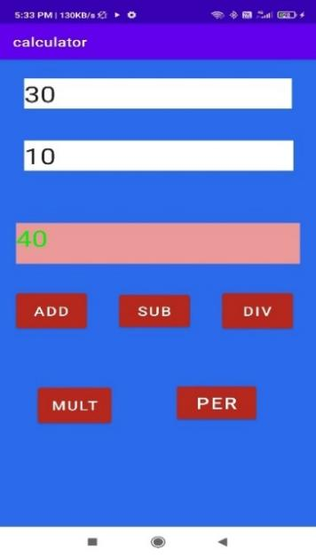 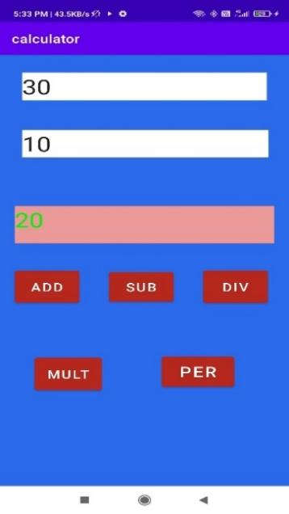

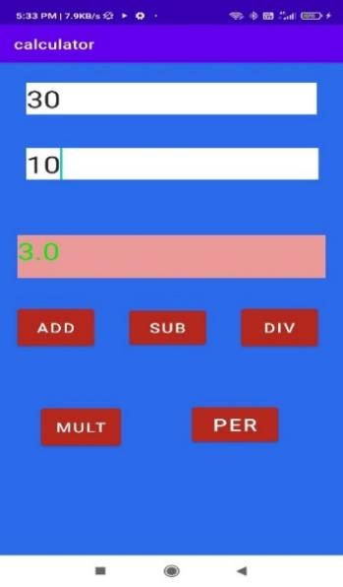 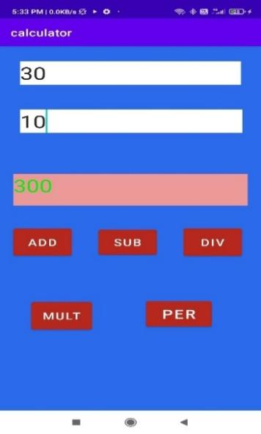 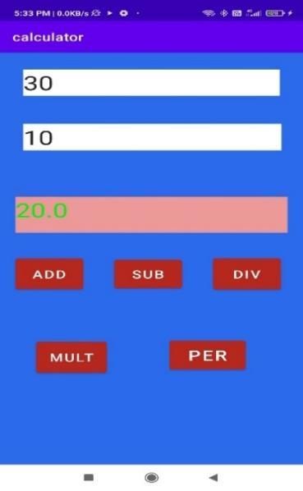

**DATE OF PRACTICAL-**13 SEPTEMBER 2022

**PROBLEM STATEMENT:** Create An Android Application To Create A Simple Form .

**OBJECTIVE**:To Collect Basic data (Name , Age , Address , Phno ) From User And After Collecting A Data Print A Toast message “Submitted” .

**AndroidManifest.xml**

<?xml version="1.0" encoding="utf-8"?>

<manifest xmlns:android="http://schemas.android.com/apk/res/android"

xmlns:tools="http://schemas.android.com/tools">

<application

android:allowBackup="true"

android:dataExtractionRules="@xml/data_extraction_rules"

android:fullBackupContent="@xml/backup_rules"

android:icon="@mipmap/ic_launcher"

android:label="@string/app_name"

android:roundIcon="@mipmap/ic_launcher_round"

android:supportsRtl="true"

android:theme="@style/Theme.Samplea"

tools:targetApi="31">

<activity

android:name=".MainActivity"

android:exported="true">

<intent-filter>

<action android:name="android.intent.action.MAIN" />

<category android:name="android.intent.category.LAUNCHER" />

</intent-filter>

</activity>

</application>

</manifest>

**Colors.xml**

<?xml version="1.0" encoding="utf-8"?>

<resources>

<color name="purple_200">#FFBB86FC</color>

<color name="purple_500">#FF6200EE</color>

<color name="purple_700">#FF3700B3</color>

<color name="teal_200">#FF03DAC5</color>

<color name="teal_700">#FF018786</color>

<color name="black">#FF000000</color>

<color name="white">#FFFFFFFF</color>

</resources>

**Strings.xml**

<resources>

<string name="app_name">samplea</string>

</resources>

**Activity_main.xml**

<?xml version="1.0" encoding="utf-8"?>

<RelativeLayout xmlns:android="http://schemas.android.com/apk/res/android"

xmlns:app="http://schemas.android.com/apk/res-auto"

xmlns:tools="http://schemas.android.com/tools"

android:layout_width="match_parent"

android:layout_height="match_parent"

tools:context=".MainActivity"

>

<TextView

android:id="@+id/textView"

android:layout_width="wrap_content"

android:layout_height="47dp"

android:layout_alignParentEnd="true"

android:layout_alignParentBottom="true"

android:layout_marginEnd="307dp"

android:layout_marginBottom="666dp"

android:text="Name : "

android:textSize="25dp"

android:textStyle="bold"

android:textColor="@color/black"

/>

<EditText

android:id="@+id/editTextTextPersonName"

android:layout_width="266dp"

android:layout_height="wrap_content"

android:layout_alignParentStart="true"

android:layout_alignParentTop="true"

android:layout_alignParentEnd="true"

android:layout_marginStart="132dp"

android:layout_marginTop="16dp"

android:layout_marginEnd="13dp"

android:ems="10"

android:inputType="textPersonName" />

<TextView

android:id="@+id/textView2"

android:layout_width="75dp"

android:layout_height="46dp"

android:layout_alignParentStart="true"

android:layout_alignParentTop="true"

android:layout_alignParentBottom="true"

android:layout_marginStart="24dp"

android:layout_marginTop="80dp"

android:layout_marginBottom="605dp"

android:text="Age : "

android:textColor="@color/black"

android:textSize="25dp"

android:textStyle="bold" />

<EditText

android:id="@+id/editTextTextPersonName2"

android:layout_width="wrap_content"

android:layout_height="wrap_content"

android:layout_below="@+id/editTextTextPersonName"

android:layout_alignParentEnd="true"

android:layout_alignParentBottom="true"

android:layout_marginStart="38dp"

android:layout_marginTop="14dp"

android:layout_marginEnd="21dp"

android:layout_marginBottom="611dp"

android:layout_toEndOf="@+id/textView2"

android:ems="10"

android:inputType="number" />

<TextView

android:id="@+id/textView3"

android:layout_width="124dp"

android:layout_height="45dp"

android:layout_alignParentEnd="true"

android:layout_alignParentBottom="true"

android:layout_marginEnd="274dp"

android:layout_marginBottom="545dp"

android:text="Address : "

android:textColor="@color/black"

android:textSize="25dp"

android:textStyle="bold" />

<EditText

android:id="@+id/editTextTextPersonName3"

android:layout_width="240dp"

android:layout_height="wrap_content"

android:layout_alignParentEnd="true"

android:layout_alignParentBottom="true"

android:layout_marginEnd="21dp"

android:layout_marginBottom="545dp"

android:ems="10"

android:inputType="textLongMessage"

android:text="" />

<TextView

android:id="@+id/textView4"

android:layout_width="122dp"

android:layout_height="wrap_content"

android:layout_alignParentStart="true"

android:layout_alignParentEnd="true"

android:layout_alignParentBottom="true"

android:layout_marginStart="16dp"

android:layout_marginEnd="273dp"

android:layout_marginBottom="489dp"

android:text="phone no : "

android:textColor="@color/black"

android:textSize="25dp"

android:textStyle="bold" />

<EditText

android:id="@+id/editTextTextPersonName4"

android:layout_width="237dp"

android:layout_height="wrap_content"

android:layout_alignParentEnd="true"

android:layout_alignParentBottom="true"

android:layout_marginEnd="17dp"

android:layout_marginBottom="484dp"

android:inputType="number"

/>

<Button

android:id="@+id/b1"

android:layout_width="105dp"

android:layout_height="62dp"

android:layout_alignParentEnd="true"

android:layout_alignParentBottom="true"

android:layout_marginEnd="147dp"

android:layout_marginBottom="326dp"

android:text="Submit" />

</RelativeLayout>

**MainActivity.java**

package com.example.samplea;

import androidx.appcompat.app.AppCompatActivity;

import android.graphics.Color;

import android.os.Bundle;

import android.view.View;

import android.widget.Button;

import android.widget.Toast;

public class MainActivity extends AppCompatActivity {

Button b1;

@Override

protected void onCreate(Bundle savedInstanceState) {

super.onCreate(savedInstanceState);

setContentView(R.layout.activity_main);

b1=findViewById(R.id.b1);

b1.setOnClickListener(new View.OnClickListener() {

@Override

public void onClick(View view) {

b1.setBackgroundColor(Color.RED);

Toast.makeText(MainActivity.this,"submitted",Toast.LENGTH_LONG).show();

}

});

}

}

**OUTPUT**

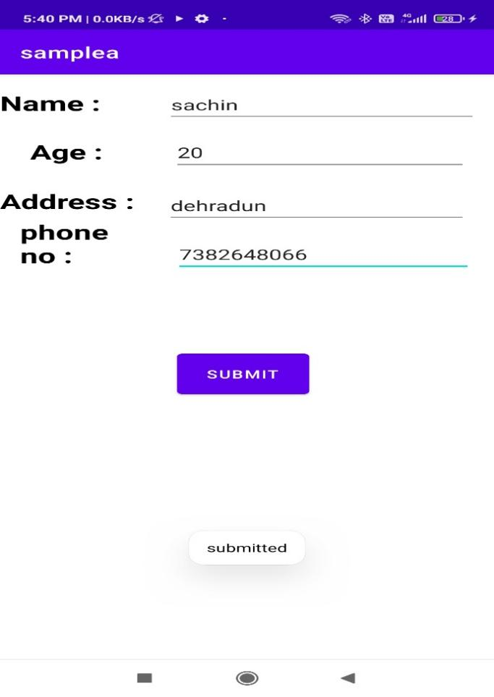

Himani Taneja

8126391576

**DATE OF PRACTICAL-**20 SEPTEMBER 2022

**PROBLEM STATEMENT:** Create an Android Application to apply image on button to change the image on an Activity on Button Click.

**OBJECTIVE**: Change the image on the activity when we click on Button.

**AndroidManifest.xml**

<?xml version="1.0" encoding="utf-8"?>

<manifest xmlns:android="http://schemas.android.com/apk/res/android"

xmlns:tools="http://schemas.android.com/tools">

<application

android:allowBackup="true"

android:dataExtractionRules="@xml/data_extraction_rules"

android:fullBackupContent="@xml/backup_rules"

android:icon="@mipmap/ic_launcher"

android:label="@string/app_name"

android:roundIcon="@mipmap/ic_launcher_round"

android:supportsRtl="true"

android:theme="@style/Theme.Buttimg"

tools:targetApi="31">

<activity

android:name=".MainActivity"

android:exported="true">

<intent-filter>

<action android:name="android.intent.action.MAIN" />

<category android:name="android.intent.category.LAUNCHER" />

</intent-filter>

<meta-data

android:name="android.app.lib_name"

android:value="" />

</activity>

</application>

</manifest>

**Colors.xml**

<?xml version="1.0" encoding="utf-8"?>

<resources>

<color name="purple_200">#FFBB86FC</color>

<color name="purple_500">#FF6200EE</color>

<color name="purple_700">#FF3700B3</color>

<color name="teal_200">#FF03DAC5</color>

<color name="teal_700">#FF018786</color>

<color name="black">#FF000000</color>

<color name="white">#FFFFFFFF</color>

</resources>

**Strings.xml**

<resources>

<string name="app_name">buttimg</string>

</resources>

**Activity_main.xml**

<?xml version="1.0" encoding="utf-8"?>

<RelativeLayout xmlns:android="http://schemas.android.com/apk/res/android"

xmlns:app="http://schemas.android.com/apk/res-auto"

xmlns:tools="http://schemas.android.com/tools"

android:layout_width="match_parent"

android:layout_height="match_parent"

tools:context=".MainActivity">

<Button

android:id="@+id/b1"

android:layout_width="84dp"

android:layout_height="60dp"

android:layout_alignParentBottom="true"

android:layout_marginBottom="377dp"

android:drawableTop="@drawable/ic_arrow"

/>

<Button

android:id="@+id/button"

android:layout_width="76dp"

android:layout_height="59dp"

android:layout_alignParentEnd="true"

android:layout_alignParentBottom="true"

android:layout_marginEnd="3dp"

android:layout_marginBottom="378dp"

android:drawableTop="@drawable/ic_baseline_arrow_back_24"

/>

<ImageView

android:id="@+id/iv1"

android:layout_width="234dp"

android:layout_height="269dp"

android:layout_alignParentEnd="true"

android:layout_alignParentBottom="true"

android:layout_marginEnd="75dp"

android:layout_marginBottom="270dp"

/>

</RelativeLayout>

**MainActivity.java**

package com.example.buttimg;

import androidx.appcompat.app.AppCompatActivity;

import android.annotation.SuppressLint;

import android.os.Bundle;

import android.view.View;

import android.widget.Button;

import android.widget.ImageView;

public class MainActivity extends AppCompatActivity {

Button b1,b2;

ImageView iv1;

int a=0;

@Override

protected void onCreate(Bundle savedInstanceState) {

super.onCreate(savedInstanceState);

setContentView(R.layout.activity_main);

b1=findViewById(R.id.b1);

b2=findViewById(R.id.button);

iv1=findViewById(R.id.iv1);

b1.setOnClickListener(new View.OnClickListener() {

@Override

public void onClick(View view) {

if (a <= 4) { a++;

if (a == 1) {

iv1.setImageResource(R.drawable.gehu);

}

if (a == 2) {

iv1.setImageResource(R.drawable.gehu1);

}

if (a == 3) {

iv1.setImageResource(R.drawable.gehu2);

}

if (a == 4) {

iv1.setImageResource(R.drawable.gehu3);

}

if (a == 5) {

iv1.setImageResource(R.drawable.gehu4);

}

}}

});

b2.setOnClickListener(new View.OnClickListener() {

@Override

public void onClick(View view) {

if (a >= 2) {a--;

if (a == 1) {

iv1.setImageResource(R.drawable.gehu);

}

if (a == 2) {

iv1.setImageResource(R.drawable.gehu1);

}

if (a == 3) {

iv1.setImageResource(R.drawable.gehu2);

}

if (a == 4) {

iv1.setImageResource(R.drawable.gehu3);

}

if (a == 5) {

iv1.setImageResource(R.drawable.gehu4);

}

}

}

});

}

}

**OUTPUT**

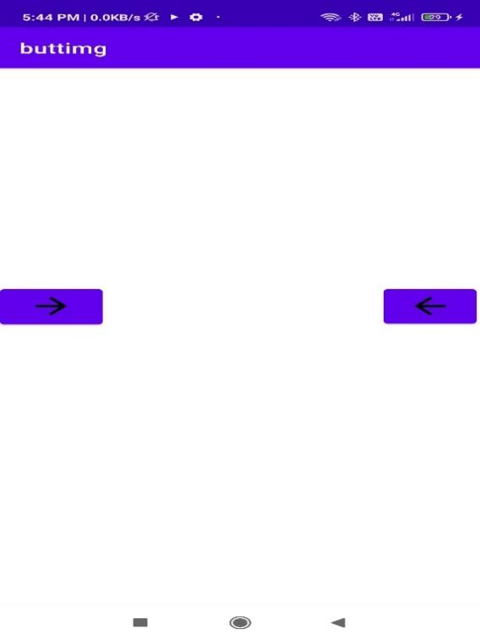 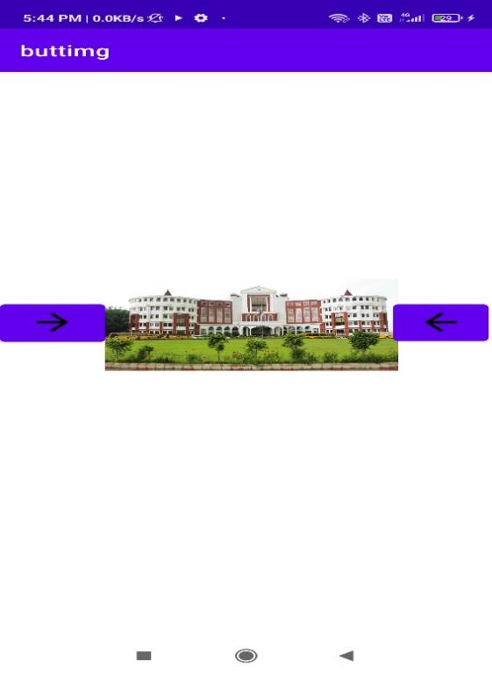

**DATE OF PRACTICAL-**20 SEPTEMBER 2022

**PROBLEM STATEMENT:** Create an application to show the use of the ListView And ArrayAdapter.

**OBJECTIVE**: We Create a two List name and RollNo and add data into them using ArrayAdapter.

**AndroidManifest.xml**

<?xml version="1.0" encoding="utf-8"?>

<manifest xmlns:android="http://schemas.android.com/apk/res/android"

xmlns:tools="http://schemas.android.com/tools">

<application

android:allowBackup="true"

android:dataExtractionRules="@xml/data_extraction_rules"

android:fullBackupContent="@xml/backup_rules"

android:icon="@mipmap/ic_launcher"

android:label="@string/app_name"

android:roundIcon="@mipmap/ic_launcher_round"

android:supportsRtl="true"

android:theme="@style/Theme.Lister"

tools:targetApi="31">

<activity

android:name=".MainActivity"

android:exported="true">

<intent-filter>

<action android:name="android.intent.action.MAIN" />

<category android:name="android.intent.category.LAUNCHER" />

</intent-filter>

</activity>

</application>

</manifest>

**Colors.xml**

<?xml version="1.0" encoding="utf-8"?>

<resources>

<color name="purple_200">#FFBB86FC</color>

<color name="purple_500">#FF6200EE</color>

<color name="purple_700">#FF3700B3</color>

<color name="teal_200">#FF03DAC5</color>

<color name="teal_700">#FF018786</color>

<color name="black">#FF000000</color>

<color name="white">#FFFFFFFF</color>

</resources>

**Strings.xml**

<resources>

<string name="app_name">lister</string>

</resources>

**Activity_main.xml**

<?xml version="1.0" encoding="utf-8"?>

<RelativeLayout xmlns:android="http://schemas.android.com/apk/res/android"

xmlns:app="http://schemas.android.com/apk/res-auto"

xmlns:tools="http://schemas.android.com/tools"

android:layout_width="wrap_content"

android:layout_height="match_parent"

tools:context=".MainActivity">

<TextView

android:layout_width="wrap_content"

android:layout_height="wrap_content"

android:text="Rollno "

android:textSize="40dp"

android:textColor="@color/black"

/>

<TextView

android:layout_width="wrap_content"

android:layout_height="wrap_content"

android:layout_marginLeft="190dp"

android:text="Name "

android:textSize="40dp"

android:textColor="@color/black"

/>

<ListView

android:id="@+id/l2"

android:layout_width="223dp"

android:layout_height="681dp"

android:layout_alignParentEnd="true"

android:layout_marginTop="50dp"

android:layout_marginEnd="4dp"

/>

<ListView

android:id="@+id/l1"

android:layout_width="173dp"

android:layout_height="681dp"

android:layout_alignParentStart="true"

android:layout_marginTop="50dp"

/>

</RelativeLayout>

**list1.xml**

<?xml version="1.0" encoding="utf-8"?>

<LinearLayout xmlns:android="http://schemas.android.com/apk/res/android"

android:layout_width="match_parent"

android:layout_height="match_parent">

<TextView

android:layout_width="wrap_content"

android:layout_height="wrap_content"

android:textSize="100px"

android:id="@+id/t1"

android:textColor="@color/black"

/>

<TextView

android:layout_width="wrap_content"

android:layout_height="wrap_content"

android:textSize="100px"

android:id="@+id/t2"

android:textColor="@color/black"

/>

</LinearLayout>

**MainActivity.java**

package com.example.lister;

import androidx.appcompat.app.AppCompatActivity;

import android.os.Bundle;

import android.widget.ArrayAdapter;

import android.widget.ListView;

import java.util.List;

public class MainActivity extends AppCompatActivity {

ListView l1,l2;

@Override

protected void onCreate(Bundle savedInstanceState) {

super.onCreate(savedInstanceState);

setContentView(R.layout.activity_main);

l1=findViewById(R.id.l1);

l2=findViewById(R.id.l2);

String list[]={"sam","python","java"};

Integer lis[]={1,2,3};

ArrayAdapter<Integer> ad=new ArrayAdapter<Integer>(MainActivity.this,R.layout.list1,R.id.t1,lis);

ArrayAdapter<String> sa=new ArrayAdapter<String>(MainActivity.this,R.layout.list1,R.id.t2,list);

l1.setAdapter(ad);

l2.setAdapter(sa);}

}

**OUTPUT**

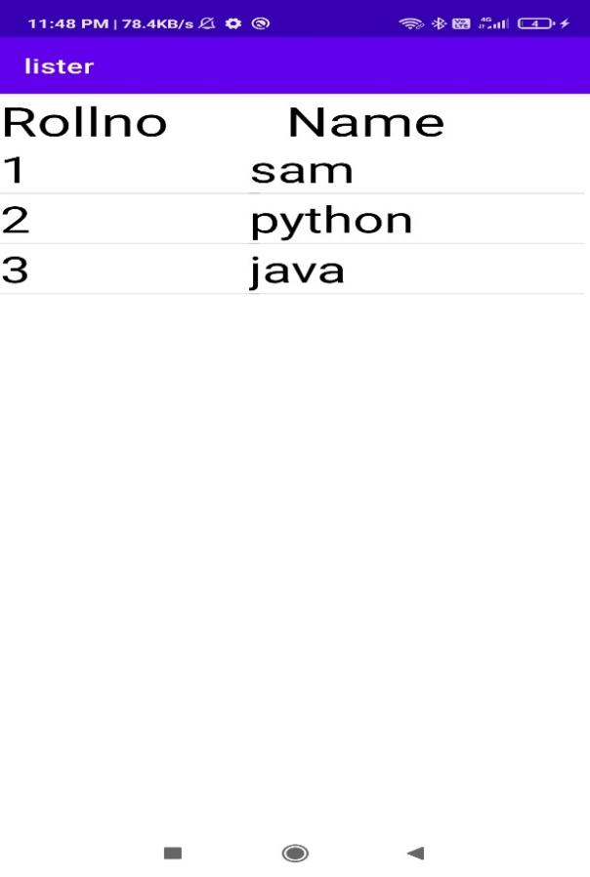

**DATE OF PRACTICAL-**20 SEPTEMBER 2022

**PROBLEM STATEMENT:** Create an android application to take the four radio button of different color name and change the TextView color according to radio button name.

**OBJECTIVE**: Change The TextView color according to radio button name.

**AndroidManifest.xml**

<?xml version="1.0" encoding="utf-8"?>

<manifest xmlns:android="http://schemas.android.com/apk/res/android"

xmlns:tools="http://schemas.android.com/tools">

<application

android:allowBackup="true"

android:dataExtractionRules="@xml/data_extraction_rules"

android:fullBackupContent="@xml/backup_rules"

android:icon="@mipmap/ic_launcher"

android:label="@string/app_name"

android:roundIcon="@mipmap/ic_launcher_round"

android:supportsRtl="true"

android:theme="@style/Theme.Radiobutt"

tools:targetApi="31">

<activity

android:name=".MainActivity"

android:exported="true">

<intent-filter>

<action android:name="android.intent.action.MAIN" />

<category android:name="android.intent.category.LAUNCHER" />

</intent-filter>

<meta-data

android:name="android.app.lib_name"

android:value="" />

</activity>

</application>

</manifest>

**Colors.xml**

<?xml version="1.0" encoding="utf-8"?>

<resources>

<color name="purple_200">#FFBB86FC</color>

<color name="purple_500">#FF6200EE</color>

<color name="purple_700">#FF3700B3</color>

<color name="teal_200">#FF03DAC5</color>

<color name="teal_700">#FF018786</color>

<color name="black">#FF000000</color>

<color name="white">#FFFFFFFF</color>

<color name="red" >#F40202</color>

</resources>

**Strings.xml**

<resources>

<string name="app_name">radiobutt</string>

</resources>

**Activity_main.xml**

<?xml version="1.0" encoding="utf-8"?>

<RelativeLayout xmlns:android="http://schemas.android.com/apk/res/android"

xmlns:app="http://schemas.android.com/apk/res-auto"

xmlns:tools="http://schemas.android.com/tools"

android:layout_width="match_parent"

android:layout_height="match_parent"

tools:context=".MainActivity"

>

<RadioGroup

android:layout_height="wrap_content"

android:layout_width="wrap_content"

android:id="@+id/rg1"

>

<RadioButton

android:layout_width="wrap_content"

android:layout_height="wrap_content"

android:text="BLUE"

android:textSize="30dp"

android:id="@+id/r1"

android:padding="20dp"/>

<RadioButton

android:layout_width="wrap_content"

android:layout_height="wrap_content"

android:text="GREEN"

android:id="@+id/r2"

android:textSize="30dp"

android:padding="20dp"/>

<RadioButton

android:layout_width="wrap_content"

android:layout_height="wrap_content"

android:text="RED"

android:id="@+id/r3"

android:textSize="30dp"

android:padding="20dp"/>

<RadioButton

android:layout_width="wrap_content"

android:layout_height="wrap_content"

android:text="YELLOW"

android:textSize="30dp"

android:id="@+id/r4"

android:padding="20dp"/>

</RadioGroup>

<TextView

android:id="@+id/t1"

android:layout_width="272dp"

android:layout_height="149dp"

android:layout_alignParentStart="true"

android:layout_alignParentEnd="true"

android:layout_alignParentBottom="true"

android:layout_marginStart="73dp"

android:layout_marginEnd="66dp"

android:layout_marginBottom="127dp"

android:background="@color/black"

/>

</RelativeLayout>

**MainActivity.java**

package com.example.radiobutt;

import androidx.appcompat.app.AppCompatActivity;

import android.graphics.Color;

import android.os.Bundle;

import android.view.View;

import android.widget.RadioButton;

import android.widget.RadioGroup;

import android.widget.TextView;

public class MainActivity extends AppCompatActivity {

RadioGroup rg;

TextView t1;

@Override

protected void onCreate(Bundle savedInstanceState) {

super.onCreate(savedInstanceState);

setContentView(R.layout.activity_main);

rg=findViewById(R.id.rg1);

rg.setOnCheckedChangeListener(new RadioGroup.OnCheckedChangeListener() {

@Override

public void onCheckedChanged(RadioGroup radioGroup, int i) {

switch(i)

{

case R.id.r1:

{

t1=findViewById(R.id.t1);

t1.setBackgroundColor(Color.BLUE);

break;

}

case R.id.r2:

{

t1=findViewById(R.id.t1);

t1.setBackgroundColor(Color.GREEN);

break;

}

case R.id.r3:

{

t1=findViewById(R.id.t1);

t1.setBackgroundColor(Color.RED);

break;

}

case R.id.r4:

{

t1=findViewById(R.id.t1);

t1.setBackgroundColor(Color.YELLOW);

break;

}

default:

{

break;

}

}

}

});

}

}

**OUTPUT**

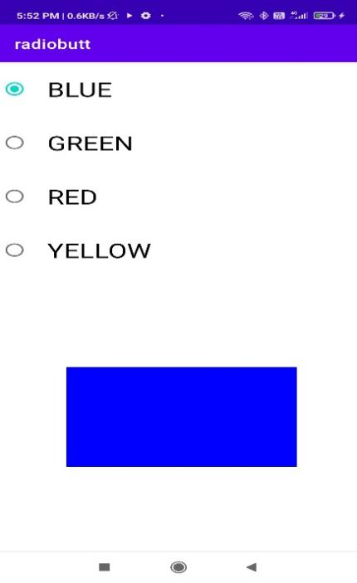 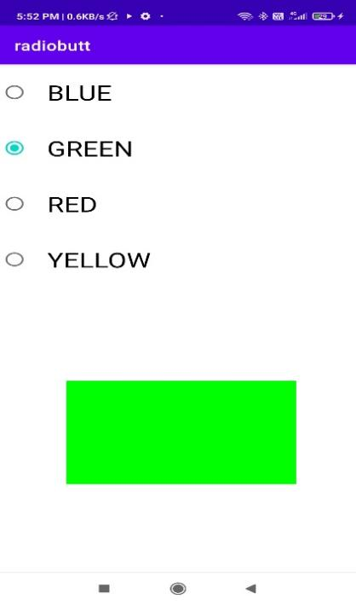

**DATE OF PRACTICAL-**27 SEPTEMBER 2022

**PROBLEM STATEMENT:** Create an android Application to Change the image on an Activity on button click.

**OBJECTIVE**: Change the Image on the activity when we click on Button.

**AndroidManifest.xml**

<?xml version="1.0" encoding="utf-8"?>

<manifest xmlns:android="http://schemas.android.com/apk/res/android"

xmlns:tools="http://schemas.android.com/tools"

package="com.example.imgehsg">

<application

android:allowBackup="true"

android:dataExtractionRules="@xml/data_extraction_rules"

android:fullBackupContent="@xml/backup_rules"

android:icon="@mipmap/ic_launcher"

android:label="@string/app_name"

android:roundIcon="@mipmap/ic_launcher_round"

android:supportsRtl="true"

android:theme="@style/Theme.Imgehsg"

tools:targetApi="31">

<activity

android:name=".MainActivity"

android:exported="true">

<intent-filter>

<action android:name="android.intent.action.MAIN" />

<category android:name="android.intent.category.LAUNCHER" />

</intent-filter>

</activity>

</application>

</manifest>

**Colors.xml**

<?xml version="1.0" encoding="utf-8"?>

<resources>

<color name="purple_200">#FFBB86FC</color>

<color name="purple_500">#FF6200EE</color>

<color name="purple_700">#FF3700B3</color>

<color name="teal_200">#FF03DAC5</color>

<color name="teal_700">#FF018786</color>

<color name="black">#FF000000</color>

<color name="white">#FFFFFFFF</color>

<color name="RED">#E01203</color>

</resources>

**Strings.xml**

<resources>

<string name="app_name">imgehsg</string>

</resources>

**Activity_main.xml**

<?xml version="1.0" encoding="utf-8"?>

<RelativeLayout xmlns:android="http://schemas.android.com/apk/res/android"

xmlns:app="http://schemas.android.com/apk/res-auto"

xmlns:tools="http://schemas.android.com/tools"

android:layout_width="match_parent"

android:layout_height="match_parent"

tools:context=".MainActivity">

<Button

android:id="@+id/b1"

android:layout_width="wrap_content"

android:layout_height="wrap_content"

android:layout_marginTop="36dp"

android:layout_marginLeft="150dp"

android:backgroundTint="@color/RED"

android:text="NEXT"

android:textSize="30dp" />

<ImageView

android:id="@+id/imageView"

android:layout_width="364dp"

android:layout_height="371dp"

android:layout_below="@+id/b1"

android:layout_alignParentStart="true"

android:layout_alignParentEnd="true"

android:layout_marginStart="21dp"

android:layout_marginTop="77dp"

android:layout_marginEnd="26dp"

/>

<Button

android:id="@+id/button"

android:layout_width="wrap_content"

android:layout_height="wrap_content"

android:layout_below="@+id/imageView"

android:layout_alignParentEnd="true"

android:layout_alignParentBottom="true"

android:layout_marginTop="75dp"

android:layout_marginEnd="131dp"

android:layout_marginBottom="58dp"

android:text="Previous"

android:textSize="20dp"

/>

</RelativeLayout>

**MainActivity.java**

package com.example.imgehsg;

import android.os.Bundle;

import android.view.View;

import android.widget.Button;

import android.widget.ImageView;

import androidx.appcompat.app.AppCompatActivity;

public class MainActivity extends AppCompatActivity {

Button b1,b2;

ImageView iv1;

int a=0;

@Override

protected void onCreate(Bundle savedInstanceState) {

super.onCreate(savedInstanceState);

setContentView(R.layout.activity_main);

b1=findViewById(R.id.b1);

b2=findViewById(R.id.button);

iv1=findViewById(R.id.imageView);

b1.setOnClickListener(new View.OnClickListener() {

@Override

public void onClick(View view) {

if (a <= 4) { a++;

if (a == 1) {

iv1.setImageResource(R.drawable.gehu);

}

if (a == 2) {

iv1.setImageResource(R.drawable.gehu1);

}

if (a == 3) {

iv1.setImageResource(R.drawable.gehu2);

}

if (a == 4) {

iv1.setImageResource(R.drawable.gehu3);

}

if (a == 5) {

iv1.setImageResource(R.drawable.gehu4);

}

}

}

});

b2.setOnClickListener(new View.OnClickListener() {

@Override

public void onClick(View view) {

if (a >= 2) {a--;

if (a == 1) {

iv1.setImageResource(R.drawable.gehu);

}

if (a == 2) {

iv1.setImageResource(R.drawable.gehu1);

}

if (a == 3) {

iv1.setImageResource(R.drawable.gehu2);

}

if (a == 4) {

iv1.setImageResource(R.drawable.gehu3);

}

if (a == 5) {

iv1.setImageResource(R.drawable.gehu4);

}

}

}

});

}

}

**OUTPUT**

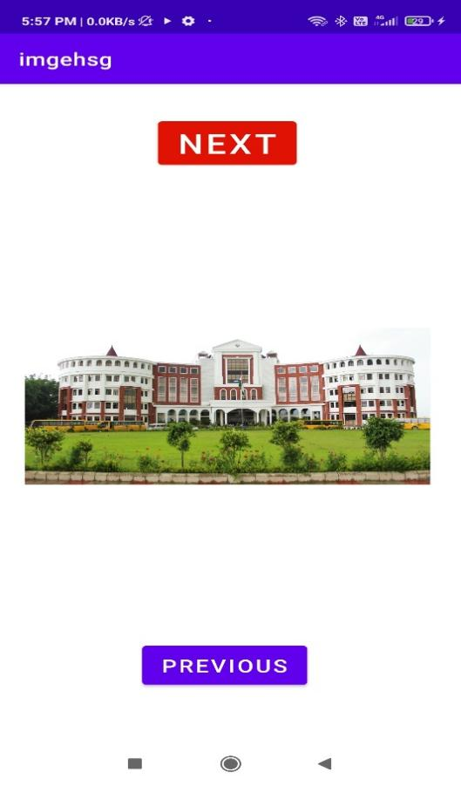

**DATE OF PRACTICAL**-27 SEPTEMBER 2022

PROBLEM STATEMENT: Create an android application to implement ToggleButton having two values on and off and insert submit button when user submit the button then the toast will notify us either ToggleButton is ON or OFF.

OBJECTIVE: To Genrate different toast message when click on submit button.

**AndroidManifest.xml**

<?xml version="1.0" encoding="utf-8"?>

<manifest xmlns:android="http://schemas.android.com/apk/res/android"

xmlns:tools="http://schemas.android.com/tools">

<application

android:allowBackup="true"

android:dataExtractionRules="@xml/data_extraction_rules"

android:fullBackupContent="@xml/backup_rules"

android:icon="@mipmap/ic_launcher"

android:label="@string/app_name"

android:roundIcon="@mipmap/ic_launcher_round"

android:supportsRtl="true"

android:theme="@style/Theme.Toggle"

tools:targetApi="31">

<activity

android:name=".MainActivity"

android:exported="true">

<intent-filter>

<action android:name="android.intent.action.MAIN" />

<category android:name="android.intent.category.LAUNCHER" />

</intent-filter>

<meta-data

android:name="android.app.lib_name"

android:value="" />

</activity>

</application>

</manifest>

**Colors.xml**

<?xml version="1.0" encoding="utf-8"?>

<resources>

<color name="purple_200">#FFBB86FC</color>

<color name="purple_500">#FF6200EE</color>

<color name="purple_700">#FF3700B3</color>

<color name="teal_200">#FF03DAC5</color>

<color name="teal_700">#FF018786</color>

<color name="black">#FF000000</color>

<color name="white">#FFFFFFFF</color>

<color name="green">#22BB85</color>

</resources>

**Strings.xml**

<resources>

<string name="app_name">toggle</string>

</resources>

**Activity_main.xml**

<?xml version="1.0" encoding="utf-8"?>

<RelativeLayout xmlns:android="http://schemas.android.com/apk/res/android"

xmlns:app="http://schemas.android.com/apk/res-auto"

xmlns:tools="http://schemas.android.com/tools"

android:layout_width="match_parent"

android:layout_height="match_parent"

tools:context=".MainActivity"

android:background="@color/green"

>

<ToggleButton

android:layout_width="wrap_content"

android:layout_height="wrap_content"

android:id="@+id/tg1"

android:layout_marginTop="200dp"

android:layout_marginLeft="150dp"

/>

<Button

android:layout_width="wrap_content"

android:layout_height="wrap_content"

android:layout_alignParentStart="true"

android:layout_marginTop="300dp"

android:text="submit"

android:id="@+id/b1"

android:layout_marginLeft="150dp"

/>

</RelativeLayout>

**MainActivity.java**

package com.example.toggle;

import androidx.appcompat.app.AppCompatActivity;

import android.annotation.SuppressLint;

import android.os.Bundle;

import android.view.View;

import android.widget.Button;

import android.widget.Toast;

import android.widget.ToggleButton;

public class MainActivity extends AppCompatActivity {

Button b1;

ToggleButton tg;

@SuppressLint("MissingInflatedId")

@Override

protected void onCreate(Bundle s) {

super.onCreate(s);

setContentView(R.layout.activity_main);

tg=findViewById(R.id.tg1);

b1=findViewById(R.id.b1);

b1.setOnClickListener(new View.OnClickListener() {

@Override

public void onClick(View view) {

String res;

res=tg.getText().toString();

Toast.makeText(MainActivity.this,res,Toast.LENGTH_LONG).show();

}

});}

}

**OUTPUT**

**DATE OF PRACTICAL-**04 OCTOBER 2022

**PROBLEM STATEMENT:** Create an android application to implement AutoCompleteTextView.

**OBJECTIVE**: To learn how to use AutoCompeleteTextView .

**AndroidManifest.xml**

<?xml version="1.0" encoding="utf-8"?>

<manifest xmlns:android="http://schemas.android.com/apk/res/android"

xmlns:tools="http://schemas.android.com/tools">

<application

android:allowBackup="true"

android:dataExtractionRules="@xml/data_extraction_rules"

android:fullBackupContent="@xml/backup_rules"

android:icon="@mipmap/ic_launcher"

android:label="@string/app_name"

android:roundIcon="@mipmap/ic_launcher_round"

android:supportsRtl="true"

android:theme="@style/Theme.New"

tools:targetApi="31">

<activity

android:name=".MainActivity"

android:exported="true">

<intent-filter>

<action android:name="android.intent.action.MAIN" />

<category android:name="android.intent.category.LAUNCHER" />

</intent-filter>

<meta-data

android:name="android.app.lib_name"

android:value="" />

</activity>

</application>

</manifest>

**Colors.xml**

<?xml version="1.0" encoding="utf-8"?>

<resources>

<color name="purple_200">#FFBB86FC</color>

<color name="purple_500">#FF6200EE</color>

<color name="purple_700">#FF3700B3</color>

<color name="teal_200">#FF03DAC5</color>

<color name="teal_700">#FF018786</color>

<color name="black">#FF000000</color>

<color name="white">#FFFFFFFF</color>

</resources>

**Strings.xml**

<resources>

<string name="app_name">new</string>

</resources>

**Activity_main.xml**

<?xml version="1.0" encoding="utf-8"?>

<RelativeLayout xmlns:android="http://schemas.android.com/apk/res/android"

xmlns:app="http://schemas.android.com/apk/res-auto"

xmlns:tools="http://schemas.android.com/tools"

android:layout_width="match_parent"

android:layout_height="match_parent"

tools:context=".MainActivity">

<AutoCompleteTextView

android:layout_width="100dp"

android:layout_height="50dp"

android:textSize="30dp"

android:layout_marginTop="70dp"

android:layout_marginLeft="40dp"

android:id="@+id/a1"

android:outlineAmbientShadowColor="@color/black"

/>

</RelativeLayout>

**MainActivity.java**

package com.example.anew;

import androidx.appcompat.app.AppCompatActivity;

import android.annotation.SuppressLint;

import android.os.Bundle;

import android.widget.ArrayAdapter;

import android.widget.AutoCompleteTextView;

public class MainActivity extends AppCompatActivity {

String lang[]={"c","c++","java","net","iphone"};

AutoCompleteTextView act;

@SuppressLint("MissingInflatedId")

@Override

protected void onCreate(Bundle savedInstanceState) {

super.onCreate(savedInstanceState);

setContentView(R.layout.activity_main);

act=findViewById(R.id.a1);

ArrayAdapter<String> ad=new ArrayAdapter<String>(MainActivity.this,android.R.layout.select_dialog_item,lang);

act.setThreshold(2);

act.setAdapter(ad);

}

}

**OUTPUT**

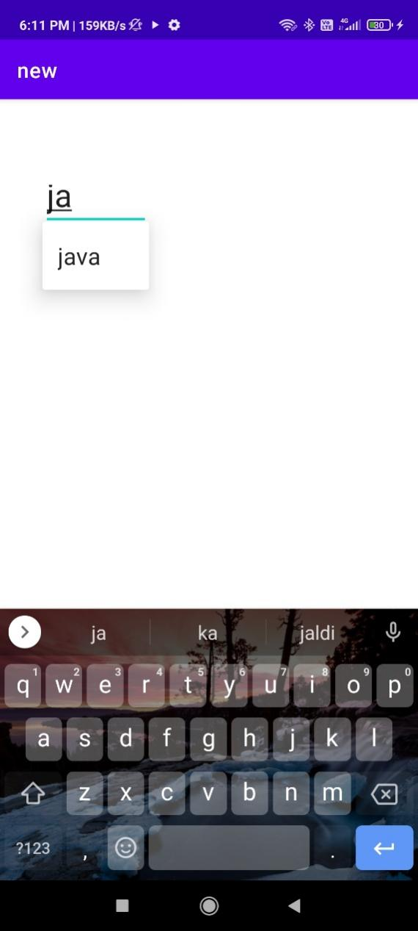

The

T